Name: A. Abhishek Reddy
Rg no:192424192
Activity-1
R-Programming
Scenario 1: Student Academic Performance Dashboard
A. Code
Attendance <- c(90, 85, 75, 95)
Marks <- c(88, 80, 70, 92)
Department <- c("CSE", "AI", "IT", "ECE")
col <- c("red", "blue", "green", "orange")
plot(Attendance, Marks,
col = col,
pch = 19,
main = "Student Academic Performance Dashboard",
xlab = "Attendance (%)",
ylab = "Internal Marks")
legend("topleft",
legend = Department,
col = col,
pch = 19)
Output:

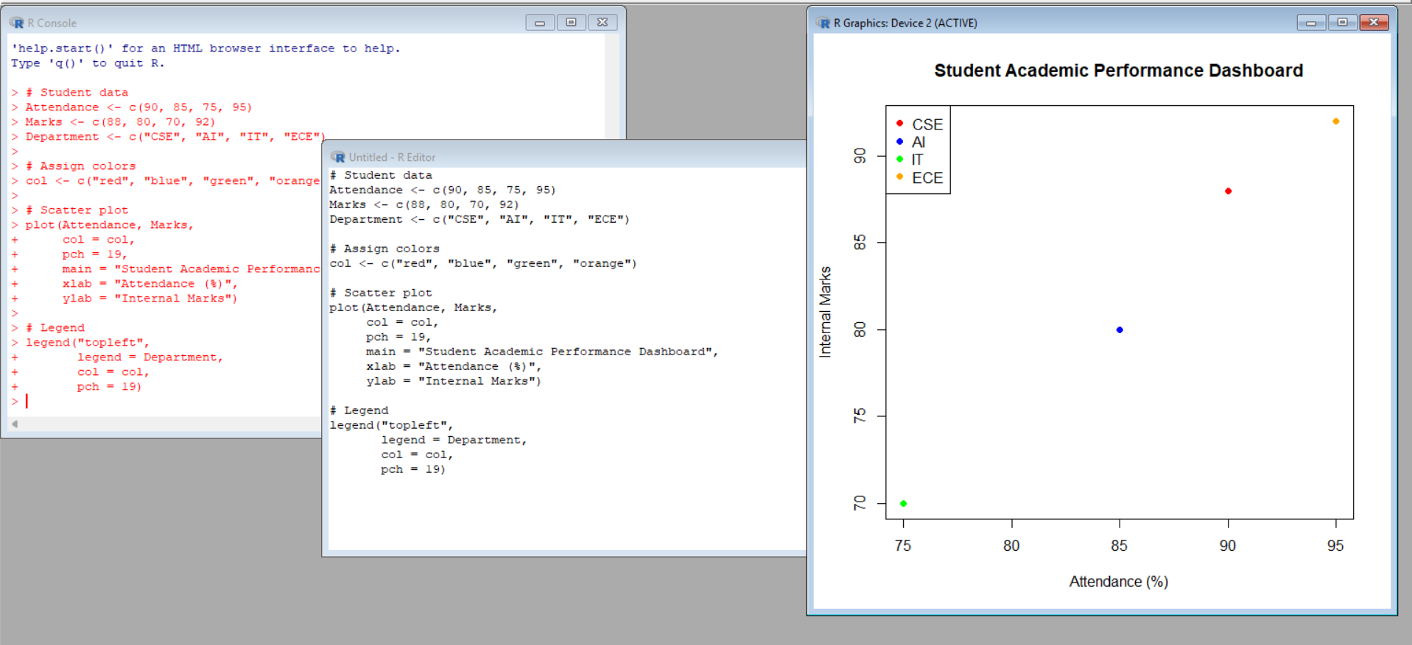
Scenario 2: Electric Vehicle Market Analysis
A. Code
Battery <- c(30, 40, 50, 60)
Price <- c(10, 15, 20, 25)
Range <- c(200, 300, 400, 500)
Manufacturer <- c("A", "B", "C", "D")
col <- c("red", "blue", "green", "orange")
symbols(Battery, Price,
circles = Range/50,
bg = col,
inches = 0.3,
xlab = "Battery Capacity (kWh)",
ylab = "Price",
main = "Electric Vehicle Market Analysis")
legend("topleft",
legend = Manufacturer,
fill = col)
Output:

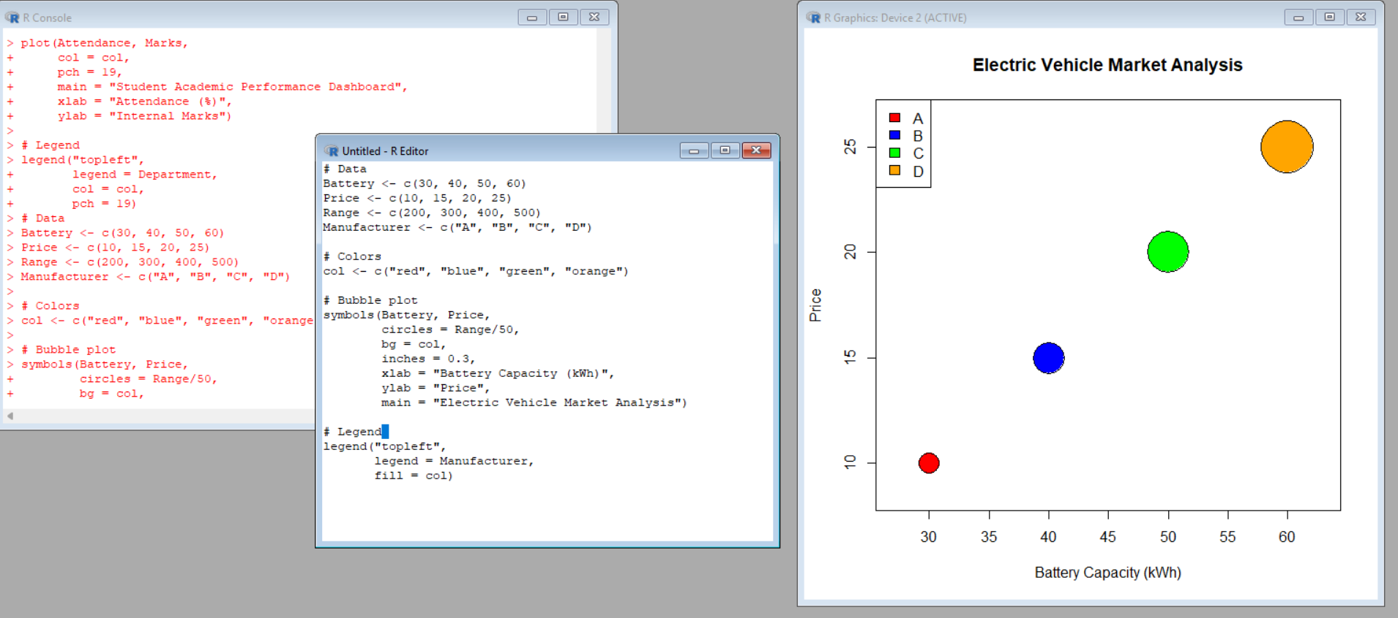

Scenario 3: Hospital Patient Admission Analysis
A. Code
Department <- c("Cardiology", "Neurology", "Orthopedics", "Pediatrics")
Patients <- c(50, 40, 35, 60)
Cost <- c(5000, 7000, 6000, 4000)
bar <- barplot(Patients,
col = c("red", "blue", "green", "orange"),
names.arg = Department,
main = "Hospital Patient Admission Analysis",
xlab = "Department",
ylab = "Number of Patients")
text(bar, Patients, labels = Cost, pos = 3)
Output:

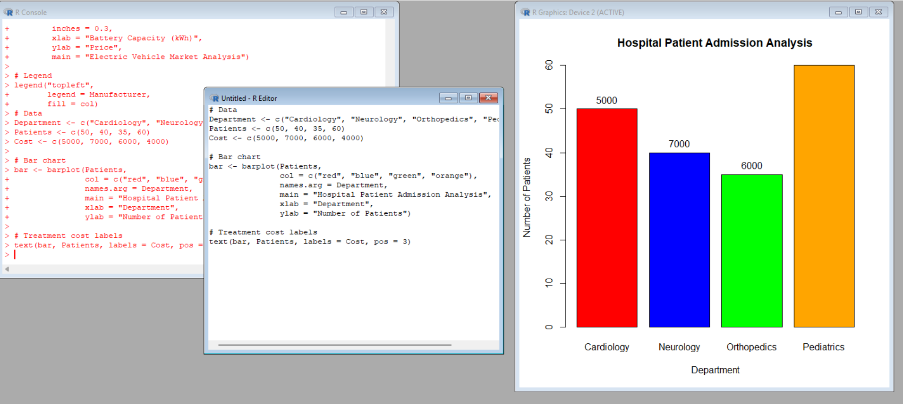

Scenario 4: Weather Monitoring System
A. Code
Day <- 1:5
Chennai <- c(34, 35, 36, 35, 37)
Delhi <- c(30, 31, 32, 31, 33)
Mumbai <- c(32, 33, 34, 33, 35)
plot(Day, Chennai, type = "l",
col = "red", lty = 1,
ylim = c(30, 38),
xlab = "Date",
ylab = "Temperature",
main = "Weather Monitoring System")
lines(Day, Delhi, col = "blue", lty = 2)
lines(Day, Mumbai, col = "green", lty = 3)
legend("topleft",
legend = c("Chennai", "Delhi", "Mumbai"),
col = c("red", "blue", "green"),
lty = c(1, 2, 3))
Output:

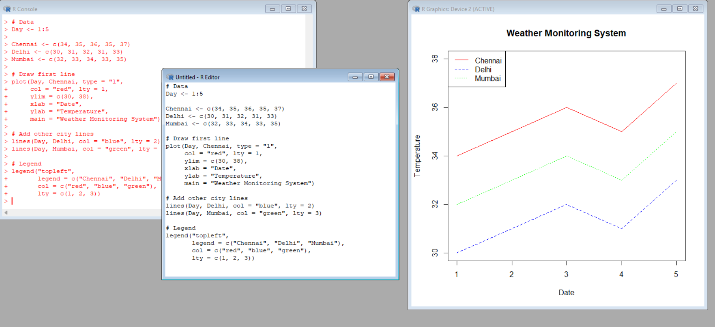
Scenario 5: Supermarket Sales Analysis
A. Code
sales <- matrix(c(100,120,140,
80,100,110,
90,110,130),
nrow = 3, byrow = TRUE)
barplot(sales,
beside = TRUE,
col = c("red", "blue", "green"),
names.arg = c("Jan", "Feb", "Mar"),
xlab = "Month",
ylab = "Sales Amount",
main = "Supermarket Sales Analysis")
legend("topleft",
legend = c("Branch A", "Branch B", "Branch C"),
fill = c("red", "blue", "green"))
Output:

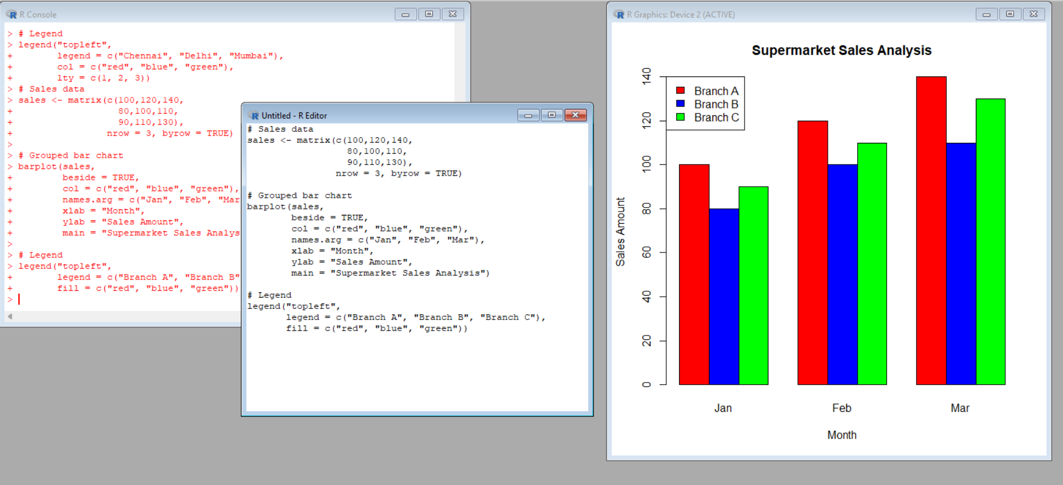

Scenario 6: Employee Salary Distribution
A. Code
Salary <- c(25000,30000,35000,40000,45000,
50000,55000,60000,65000,70000)
hist(Salary,
breaks = 5,
col = "skyblue",
main = "Employee Salary Distribution",
xlab = "Salary",
ylab = "Number of Employees")
Output:

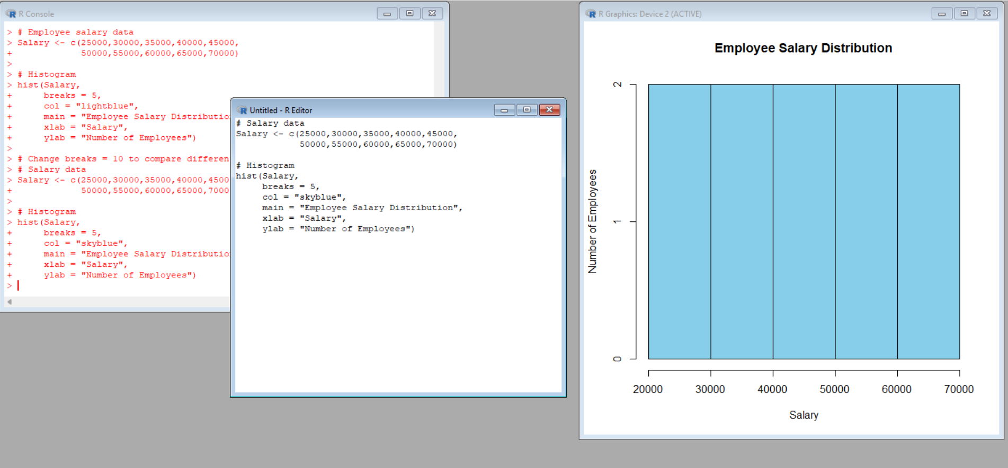

Scenario 7: Smartphone Market Comparison
A. Code
RAM <- c(4, 6, 8, 12)
Price <- c(15000, 22000, 30000, 45000)
Storage <- c(64, 128, 128, 256)
plot(RAM, Price,
pch = c(15,16,17,18),
cex = Storage/64,
col = c("red","blue","green","orange"),
main = "Smartphone Market Comparison",
xlab = "RAM (GB)",
ylab = "Price")
legend("topleft",
legend = c("Samsung","Vivo","Realme","OnePlus"),
pch = c(15,16,17,18),
col = c("red","blue","green","orange"))
Output:

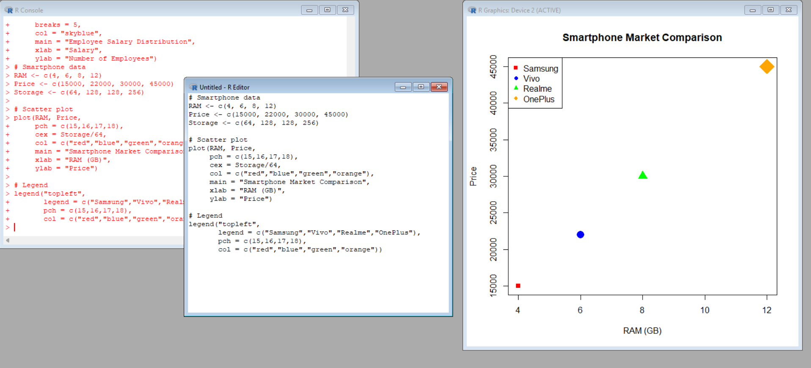

Scenario 8: Online Movie Rating Analysis
A. Code
rating <- matrix(c(4.5, 3.8, 4.2, 4.8), nrow = 2)
heatmap(rating,
Colv = NA,
Rowv = NA,
col = heat.colors(10),
main = "Online Movie Rating Analysis")
Output:

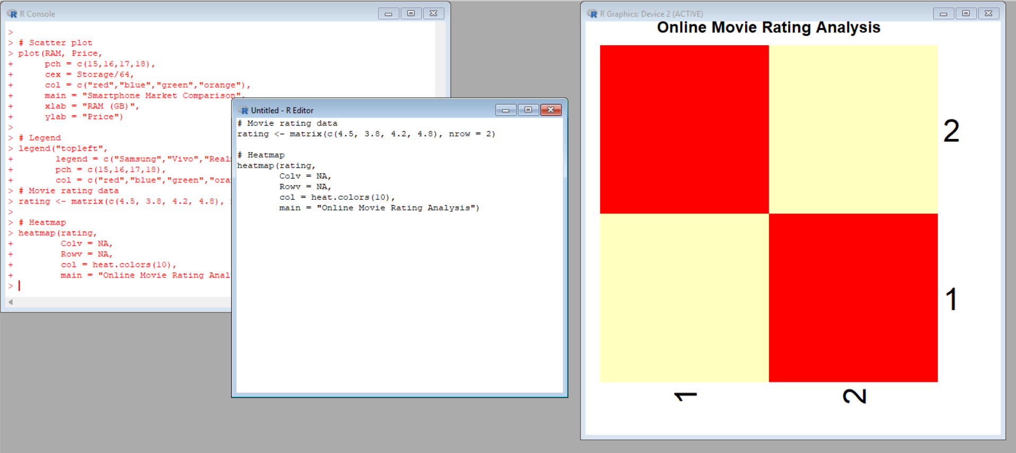

Scenario 9: COVID-19 State-wise Analysis
A. Code
State <- c("TN", "KA", "AP", "KL")
Cases <- c(5000, 8000, 3000, 7000)
data <- matrix(Cases, nrow = 1)
image(data,
col = heat.colors(4),
axes = FALSE,
main = "COVID-19 State-wise Analysis")
axis(1, at = seq(0, 1, length = 4), labels = State)
Output:

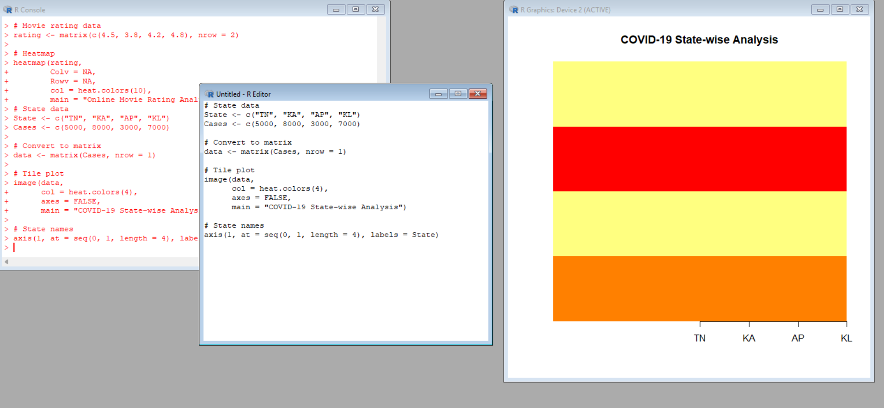

Scenario 10: Iris Flower Classification
A. Code
plot(iris$Sepal.Length,
iris$Petal.Length,
col = as.numeric(iris$Species),
pch = as.numeric(iris$Species),
cex = iris$Sepal.Width/2,
xlab = "Sepal Length",
ylab = "Petal Length",
main = "Iris Flower Classification")
legend("topleft",
legend = levels(iris$Species),
col = 1:3,
pch = 1:3)
Output:

